Water Quality Summary

Thorp and Kimball Brooks, 2017

South Chittenden River Watch

- The South Chittenden River Watch (SCRW) is a volunteer group that has been monitoring water quality in four watersheds in southern Chittenden County since 2004.
- Long term trends are tracked at a sub-watershed scale using over 30 monitoring sites (about 15 monitored per year).
- Results are used to understand baseline water quality conditions, determine effectiveness of "Best Management Practices", and identify hot spot phosphorus loading and critical source area locations in need of remediation recommendations and investments.
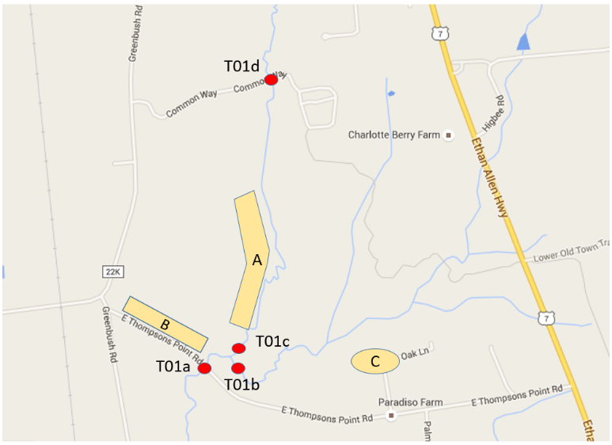
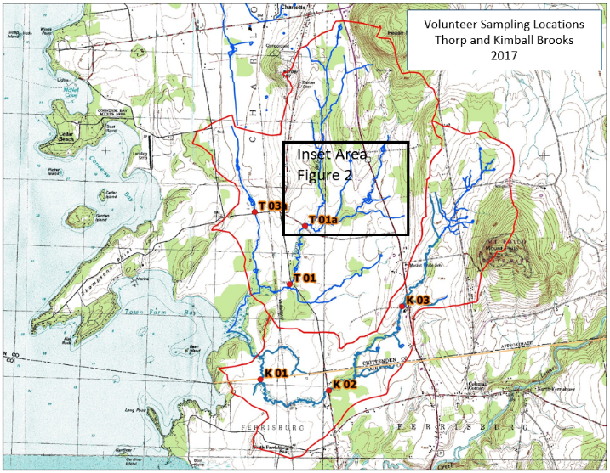
- LCA, towns, and citizens rely on SCRW monitoring data results to understand stream water quality conditions under current regulations, inform education outreach efforts, town plan and regulations updates, regional plan updates, monitor effectiveness of storm water practices and sewer treatment systems and to inform optimal conservation practices designs for water quality improvement projects.

Thorp Brook Results
- Thorp Brook was a focus study in 2017 and had 4 bracket monitoring stations to study water quality conditions above and below newly planned and implementation practices
- Thorp Brook remains stressed due to sediment and nutrient loading
- Nitrogen is consistently below State standards
- Phosphorus consistently exceeds the State standard during low flow conditions
- The western tributary of Thorp Brook (which drains the west Charlotte village and agricultural fields) is contributing more phosphorus than the upper main stem (which drains Route 7)
- Thorp Brook has high amounts of suspended sediment, largely due to easily-erodible clay soils
- Results continues to suggest the agricultural field at Thompson’s Point Rd is an area to focus on implementation
- Past data provides baseline information to monitor stormwater treatment practices to be installed at Big Oak Lane in 2018 (Thorp Brook headwaters)
- T01a is monitoring the road swale improvements along East Thompson’s Point Road. SCRW will continue to monitor to assess impacts. More information is needed to make a conclusion about water quality impacts.
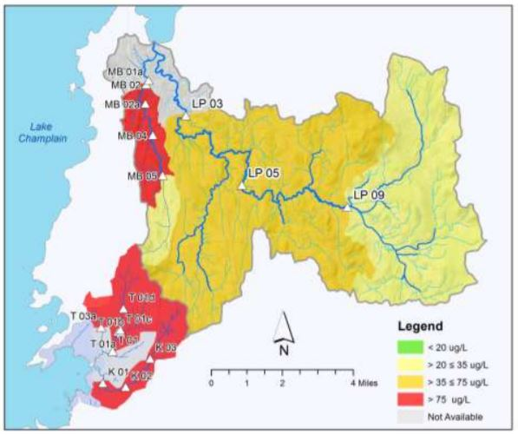
Phosphorus Loading - 2017
Kimball Brook Results
- Kimball Brook still has poor stream channel stability
- Nitrogen is consistently below State standards
- Phosphorus consistently exceeds the State standard during low flow and high flow conditions (standard only based on low flow)
- Kimball Brook has moderate levels of suspended sediment, largely due to easily-erodible clay soils
- Kimball Brook is listed as stressed by the State due to impacts to aquatic health, aesthetics, and secondary contact recreation uses resulting from development, channelization, and agricultural land uses (VTDEC, 2016b)

Tracking the Biological Health and Aquatic Habitat of Thorp and Kimball
Seventeen of Vermont’s waters are biologically impaired due to urban stormwater runoff; six of those are in Basin 5 (northern Lake Champlain drainage), including the LaPlatte. These waters fail to meet certain Vermont Water Quality Standards and are trending toward poor biological conditions based on biological monitoring data. Poor biological conditions due to stormwater impacts lead to stormwater impairment status (state/fed 303(d) list) and a required restoration plan that could cost millions of dollars to host towns. This is an indicator of where better land use planning should occur. Currently, the Munroe Brook in Shelburne is listed as stormwater impaired. Sections of the LaPlatte River also have poor biology conditions and are being studied by VT DEC, Lewis Creek Association and Lake Iroquois Association.

